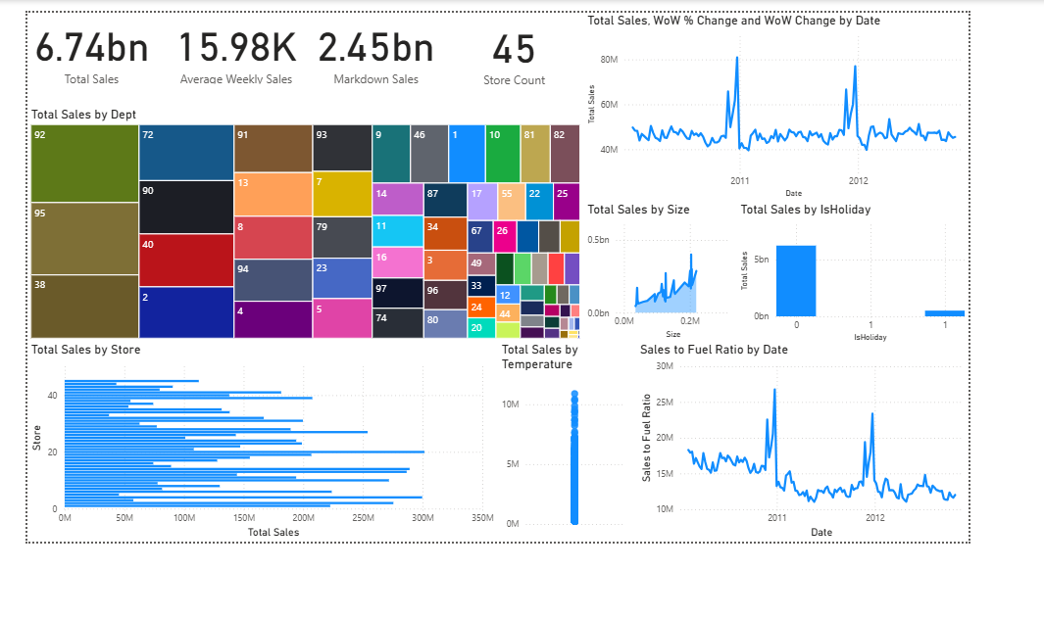
Executive Summary Dashboard – Explanation
This dashboard provides a high-level overview of Walmart’s sales performance, combining financial metrics, department behavior, store contribution, holiday impact, and external factor relationships. Each section answers a specific business question.
Top KPI Section (Overall Business Summary)
1. Total Sales – 6.74bn
Shows the total revenue generated across all stores and departments during the period.
This is the most important KPI for evaluating business scale.
2. Average Weekly Sales – 15.98K
Displays the average sales per week, helping Walmart understand weekly baseline performance.
3. Markdown Sales – 2.45bn
Represents the sales generated during markdown (promotion) periods.
This helps identify how much revenue comes from discounted items.
4. Store Count – 45
Indicates the total number of stores included in the dataset.
These KPIs immediately show business size, weekly performance, promotion dependency, and operational footprint.
Total Sales by Department (Treemap)
This treemap shows which departments contribute the most to total sales.
- Larger blocks = higher sales
- Smaller blocks = lower sales
Each department is numbered (e.g., Dept 92, 95, 38, 72 etc.).
This helps identify top-performing and low-performing departments at a glance.
Total Sales by Store (Horizontal Bar Chart)
This chart compares sales performance across all 45 stores.
- Each bar = a store
- Longer bars = higher revenue
Helps answer:
- Which stores perform best?
- Which stores need operational or marketing support?
- Are there performance gaps across locations?
Total Sales, WoW % Change & WoW Change Over Time (Line Chart)
This line chart tracks weekly sales over the entire timeline (2010–2012).
Spikes visible during:
- Major holidays
- Promotion periods
This visual is used to:
- Detect seasonal trends
- Identify holiday spikes
- Evaluate sales stability over time
Total Sales by Size (Scatter/Line Chart)
Shows the relationship between store size and sales.
Insight visible:
- Larger stores generally generate more sales
- Smaller stores have lower revenue contributions
This is useful for Walmart’s store planning and expansion strategy.
Total Sales by IsHoliday (Column Chart)
Compares sales on:
- Non-holiday weeks (0)
- Holiday weeks (1)
You can see:
- Holiday weeks show significantly higher sales
- Confirms strong holiday-driven revenue uplift
Helps measure holiday effectiveness.
Total Sales by Temperature (Scatter Chart)
Shows how sales behave against temperature changes.
Visible pattern:
- Most weekly sales cluster around similar values
- Extreme temperature does not significantly change sales
Used to check if weather influences buying behavior.
Sales to Fuel Ratio by Date (Line Chart)
Tracks the ratio of Sales ÷ Fuel Price over time.
Insights:
- Ratio drops when fuel prices rise
- Ratio spikes when fuel prices fall
Useful for:
- Understanding macroeconomic sensitivity
- Determining how fuel cost changes influence consumer spend

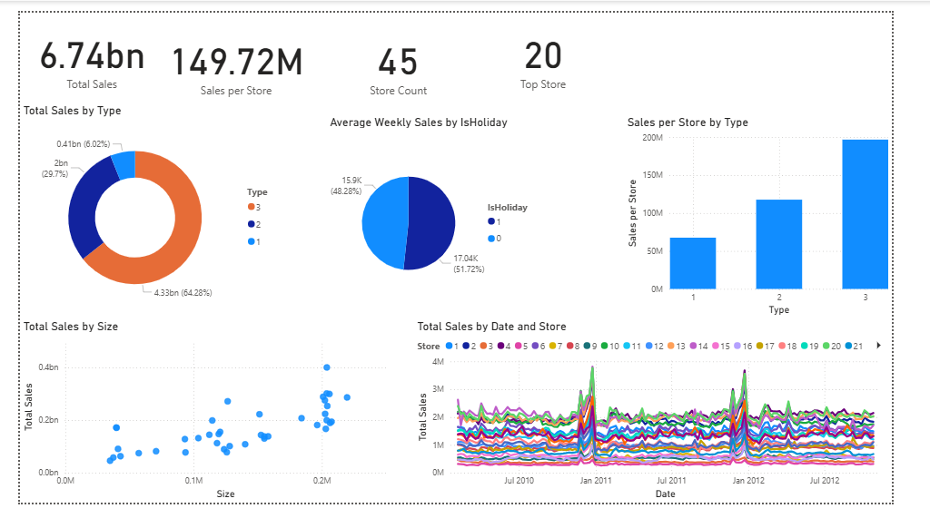
Store Performance Dashboard – Explanation
This dashboard provides a complete view of how Walmart’s 45 stores are performing across different store types, sizes, and time periods. It helps identify the top-performing stores and understand which operational factors (store type, store size, holidays) influence sales behavior.
Top KPI Section (Store-Level Overview)
These KPIs summarize the overall store performance in one glance.
1. Total Sales – 6.74bn
Shows total revenue generated by all stores combined.
2. Sales per Store – 149.72M
The average amount each store contributes to total revenue.
This helps Walmart gauge store productivity.
3. Store Count – 45
Total number of active stores in the dataset.
4. Top Performing Store – Store 20
Identifies the store with the highest total sales.
Shows which location leads overall performance.
Total Sales by Type (Donut Chart)
Stores are grouped into three types (1, 2, 3) based on store format/size.
This chart shows each type’s contribution to total revenue:
- Type 3 – 64.28% (largest contributor)
- Type 2 – 29.7%
- Type 1 – 6.02%
Store Type 3 dominates Walmart’s revenue, indicating larger or more popular store formats perform significantly better.
Average Weekly Sales by Holiday (Pie Chart)
Compares weekly sales between:
- Holiday weeks (blue, ~48.28%)
- Non-holiday weeks (~51.72%)
Despite there being fewer holiday weeks, they generate almost half of the weekly sales, showing strong seasonal demand.
Holiday periods drive major spikes and require proper inventory & staffing planning.
Sales per Store by Type (Bar Chart)
Shows average revenue per store for each store type.
- Type 1: ~50M
- Type 2: ~120M
- Type 3: ~180M
Store Type 3 not only contributes the most overall but also generates the highest revenue per store.
Total Sales by Size (Scatter Plot)
Plots store Size vs Total Sales.
Trend visible:
- Smaller stores generate lower revenue
- Mid-size stores show moderate performance
- The largest stores generate the highest sales
Confirms the positive correlation: bigger stores → more revenue.
Total Sales by Date and Store (Multi-Line Chart)
Each line represents a store.
This time-series chart shows:
- Weekly sales behavior for all 45 stores
- Clear demand spikes during holidays (e.g., late 2010, 2011, 2012)
- Relative performance differences between stores
- Seasonal patterns repeated each year
Useful for identifying growth trends, seasonal behavior, and consistently strong or weak stores.

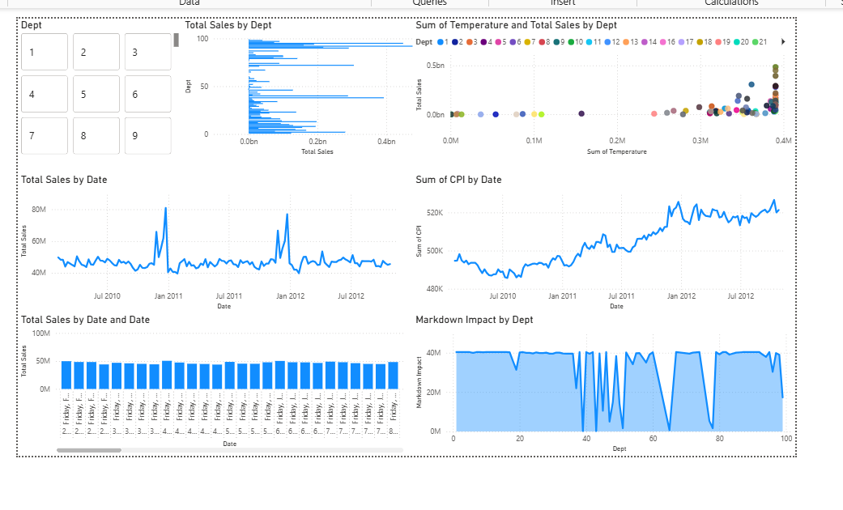
Department Analytics Dashboard – Explanation
This dashboard focuses on understanding department-level performance, highlighting how sales relate to weather, promotions, inflation, and weekly patterns. It helps the business identify strong and weak departments and understand how external factors impact departmental revenue.
1. Department Selector (Button Slicer)
At the top-left, you have a clean department selector showing Dept 1–9 (scroll for more).
Purpose:
- Quickly filter the entire dashboard
- Analyze a single department or multiple departments
- Enable department-level deep dives
Allows stakeholder to instantly compare department performance.
2. Total Sales by Department (Bar Chart)
This horizontal bar chart shows each department’s total sales.
Insights:
- Some departments (around Dept 90–100) generate significantly higher revenue
- Others contribute much less
- Helps identify top and bottom performers
Useful for product mix optimization and resource allocation.
3. Temperature vs Total Sales by Department (Scatter Plot)
This scatter plot compares:
- Sum of Temperature (x-axis)
- Total Sales (y-axis)
- Each dot = a department
Insights:
- Higher temperatures correlate with higher sales for several departments
- Certain departments are less sensitive to weather
- Some clusters show strong seasonal behavior
Useful for weather-driven product forecasting (e.g., beverages, apparel).
4. Total Sales by Date (Line Chart)
A time-series visualization showing weekly total sales trends.
Insights:
- Clear sales spikes during major holidays
- Consistent annual seasonal peaks
- After-holiday dips also visible
- General trend stays within 40–70 million weekly range
Shows long-term performance and seasonal retail patterns.
5. CPI Trend by Date (Line Chart)
Shows the Consumer Price Index over the timeline.
Why it matters:
- CPI represents inflation
- Rising CPI can indicate rising consumer prices
- Helps check if inflation correlates with sales fluctuations
Observations:
- CPI rises significantly from 2010 to 2012
- Certain sales dips align with CPI drops
Useful for macroeconomic sensitivity analysis.
6. Total Sales by Date and Day (Bar Chart)
This bar chart shows the sales split by weekday, across the entire dataset.
Insights:
- Consistent weekly pattern
- Helps identify peak shopping days
- Useful for staffing and inventory planning
Great for weekly operational optimization.
7. Markdown Impact by Department (Area Chart)
Shows how promotions (Markdowns) vary by department.
Observations:
- Some departments receive very high markdown budgets
- Others have minimal promotional impact
- Sharp drops for certain departments indicate targeted discount events
Helps identify which departments rely heavily on discounts to drive sales.

